**EXPERIMENT**- **3**

**Aim:**

1. **Write a shell script program to find factorial of a number**

**Code to find Factorial:**

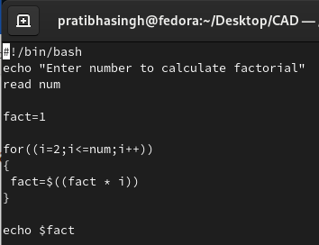

**Output:**

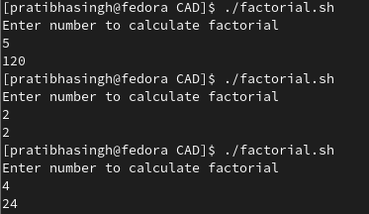

1. **Write a shell script program to sort an array in ascending order**

**Code to sort an array:**

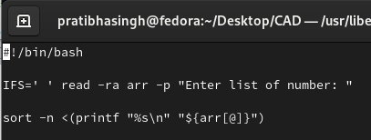

**Output:**

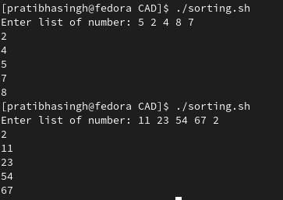

1. **Write a shell script program to display list of user currently logged in.**

**Code to display list of currently logged in user**:

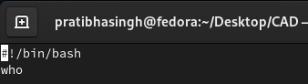

**Output:**



1. **Write a shell script program to display “HELLO WORLD”.**

**Code to display HELLO WORLD:**

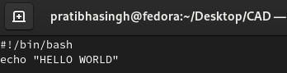

**Output:**



1. **Write a shell script program to develop a calculator.**

**Code to develop a Calculator:**

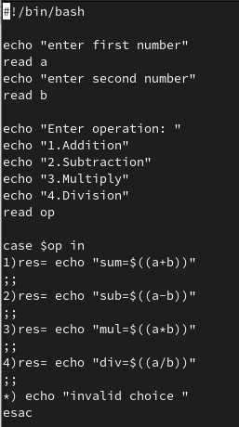

**Output:**

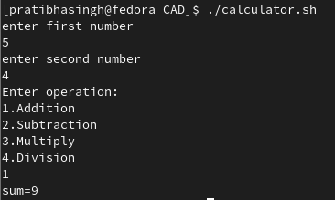

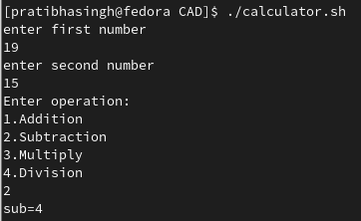

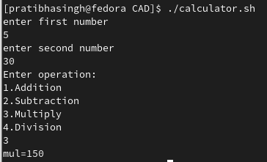

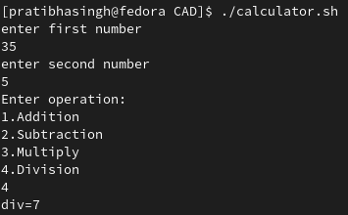

1. **Write a shell script program to check whether the given number is even or odd.**

**Code to check even odd:**

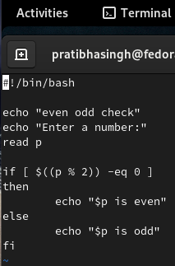

**Output:**

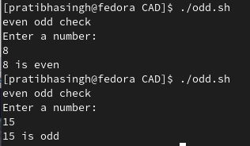

1. **Write a shell script program to search whether element is present in the list or not.**

**Code to search element presence:**

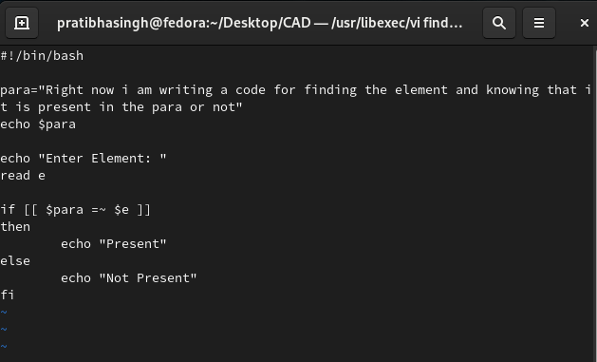

**Output:**

